SPPrintWebPart v1.0 User’s Guide

(used in Microsoft SharePoint Foundation and SharePoint 2010)

Contents

Why SPPrintWebpart: 3

Description: 3

SPPrintWebPart Features: 4

Installation: 5

Install SPPrintWebPart in sandbox. 5

Install SPPrintWebPart in farm. 5

How to use SPPrintWebPart. 6

How to customize SPPrintWebPart. 9

How to un-install SPSIteDiagram. 9

How SPPrintWebPart works: 10

Contact us: 10

# Why SPPrintWebpart:

There exists a need to print the SharePoint page without the left and top navigation elements; leaving just the main content zone. There is also a need to print a list view or a single web part within the page.

Some have come up with solutions involving java script and putting the code within the content editor web part. This solution can work for a few pages, but not for tens of sub sites or hundreds of pages. You cannot create a content editor web part for every single one of them.

SPPrintWebPart is a sandbox solution that allows for printing page content, list view, or web part across web application. This functionality is invoked within the **Site Action** menu bar. In case **Site Action** menu is not used in your site, this function can also be called from any other objects within your SharePoint.

# Description:

SPPrintWebPart is a handy SharePoint utility for printing SharePoint pages, lists, and SharePoint web parts. SPPrintWebPart comes as a SharePoint feature that adds additional menu items under the **Site Actions** Menu bar. SPPrintWebPart is easy to install and easy to configure as a Sandbox solution.

After installation of the utility by activating the SPPrintWebPart feature, you have access to the Print functionality from the **Site Actions** Menu item.

Using SPPrintWebPart library, you can add a print functionality on any page.

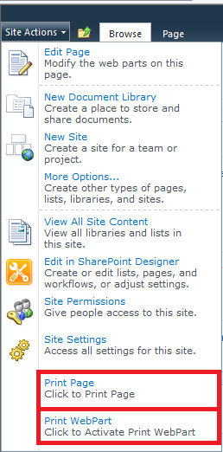

SPPrintWebPart can easily be extended and customized by a client. Full source code is available for a client to add extra functionality, such as printing multiple web parts simultaneously, etc...

# SPPrintWebPart Features:

Can be installed on sandbox

Can print SharePoint page

Can print SharePoint web parts

Can print SharePoint lists

Can be installed and customized easily

# Installation:

SPPrintWebPart comes with a WSP file that can be easily deployed. You can install SPPrintwebPart either in **sandbox** (top-level site) or in **farm**.

Within the zip file there is a sample of both install and uninstall PowerShell commands that can be referenced during the installation.

## Install SPPrintWebPart in sandbox.

1. On the top-level site of the site collection, on the **Site Actions** menu, click **Site Settings**.
2. On the Site Settings page, in the **Galleries** section, click **Solutions**.
3. On the Solutions tab of the ribbon, in the New group, click Upload Solution.
4. In the **Upload Document** dialog box, click **Browse**.
5. In the **Choose File to Upload** dialog box, find the file share, click the WSP file, and then click **Open**.
6. In the **Upload Document** dialog box, click **OK**. The **Solution Gallery – Activate Solution** dialog box appears.
7. In the **Solution Gallery – Activate Solution** dialog box, click **Activate**.
8. Go to your site and from **Site Actions**, **Site Settings**, **Manage Site Features,** choose **Activate** SPPrint WebPart feature, if it is not already activated.



## Install SPPrintWebPart in farm.

1. Run **SharePoint 2010 Management shell** as an **administrator**:

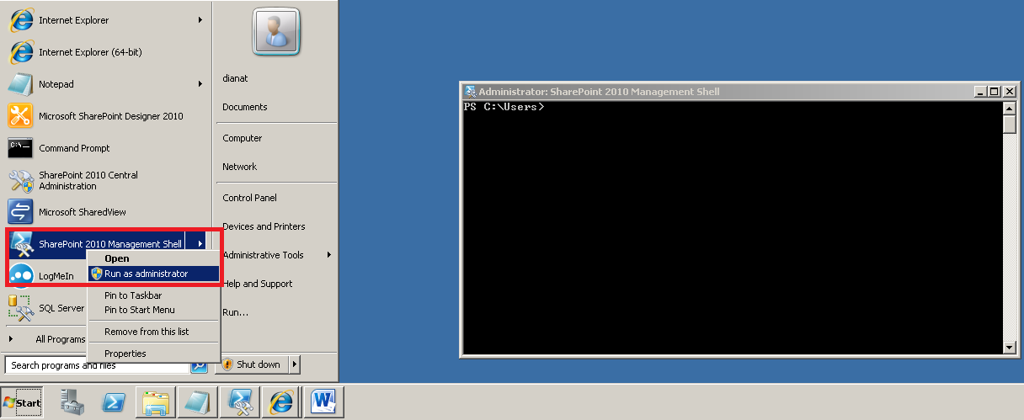

1. Run the following command to add SPPrintWebPart solution:

**Add-SPSolution -LiteralPath** **"*C:\download\*** ***SPPrintWebPart\SPPrintWebPart.wsp*" -Confirm:$false**

The *C:\download* ***SPPrintWebPart*** path is the location where you have copied the ***SPPrintWebPart***.wsp file.

Keep in mind Management Shell commands are case-sensitive.

1. Then run the following to install the solution:

**Install-SPSolution –Identity SPPrintWebPart.wsp –GACDeployment -Confirm:$false**

1. Go to your site and from **Site Actions**, **Site Settings**, **Manage Site Features,** choose **Activate** SPPrint WebPart feature, if it is not already activated.



# How to use SPPrintWebPart.

After the feature is activated you can use the print functionality on each page. Now on **Site Actions**, there aretwo additional menu items: **Print Page** and **Print Web Part**.

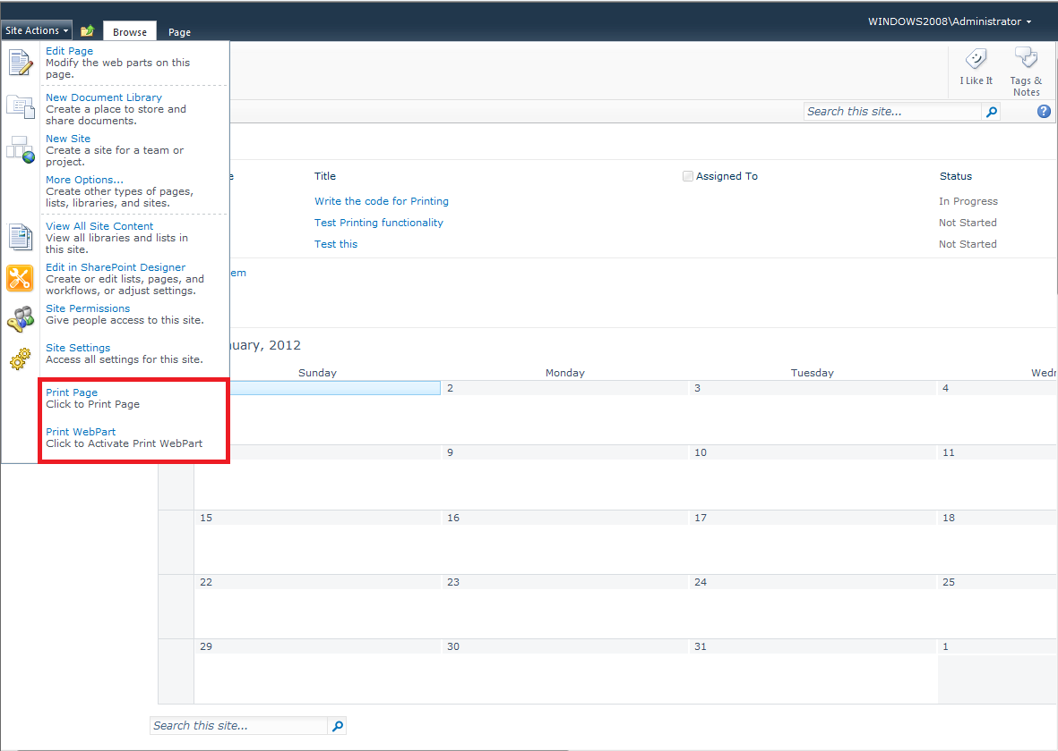

**Print Page** menu itemis used to print the whole page without the left and top navigation elements; leaving just the main content zone.

**Print Web Part** menu item activates print functionality for printing web parts within the page. By clicking on **Print Web Part**, the print icon is displayed on each individual web part, as you see below:

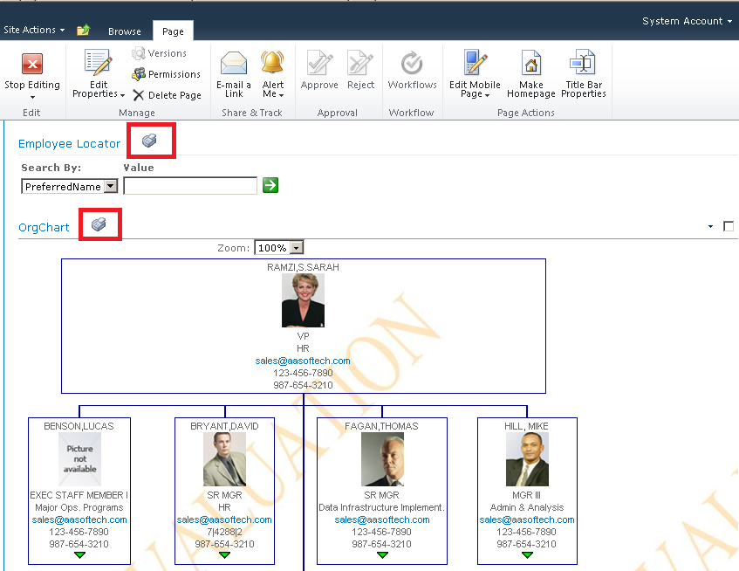

You can then click on each icon to print that particular web part.

When you click on Print icon on desired web part, you will see the web part in a new window.

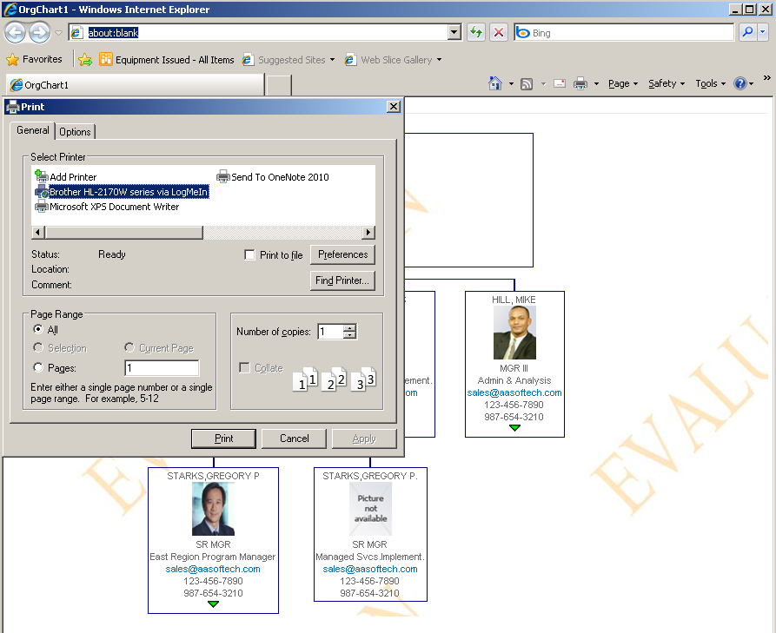

The above example shows how to print OrgChart WebPart using SPPrintWebPart.

# How to customize SPPrintWebPart.

SPPrintWebPart can be fully customized. The source code and guidelines for modifying the web part will be supplied after product purchase.

# How to un-install SPSIteDiagram.

1. Start **SharePoint 2010 Management shell** as an administrator:

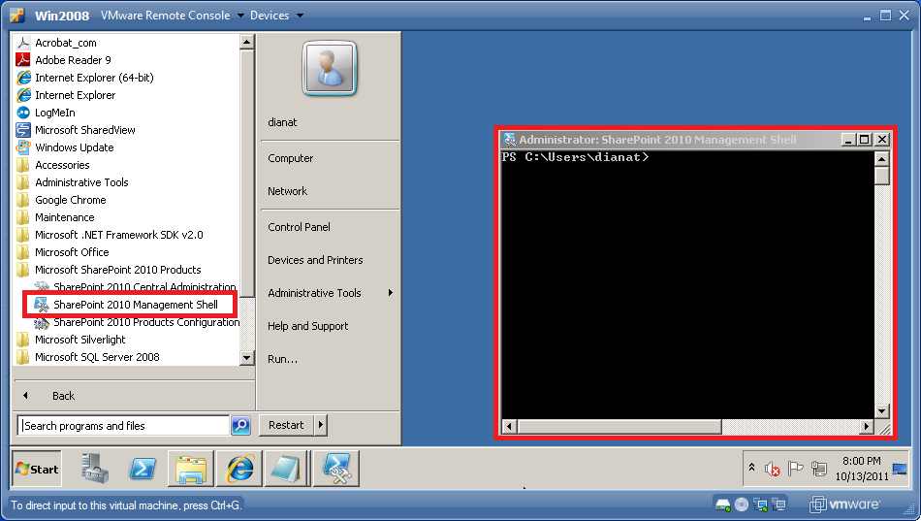

1. Run the following command to uninstall the solution:

**Uninstall-SPSolution -Identity *SPPrintWebPart* -Confirm:$false**

1. Run the following command to remove the solution:

**Remove-SPSolution -Identity *SPPrintWebPart* -Confirm:$false**

# How SPPrintWebPart works:

SPPrintWebPart (version 1.0) prints SharePoint page, SharePoint lists and SharePoint web parts. The print function is called by clicking one of the additional menu items under site actions. Additional menu items under site actions call java script to invoke the print functionality. If SharePoint site doesn’t use OOB Site Actions, calling the print functionality Java script should be invoked from other places. Having access to the source code allows you to know which functions to call. Source code will be provided upon purchasing the product.

# Contact us:

Do you need customization? You can contact us at:

AASoftech Inc.

1909 Baton drive,

Vienna, VA 22182

USA

[sales@aasoftech.com](mailto:sales@aasoftech.com)

<http://www.aasoftech.com>

703-795-1826